CO5

1.In database Employee.
1. find the average salary of each dept.

Query

db.empdetails.aggregate([{$group:{_id:"$Dept",salary_avg:{$avg:"$salary"}}}]);

Output

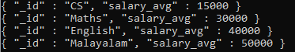

2. find the minimum salary of each dept.

Query

db.empdetails.aggregate([{$group:{_id:"$Dept",minimum_salary:{$min:"$salary"}}}]).pretty();

Output

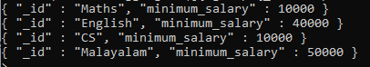

3. find the maximum salary of each dept.

Query

db.empdetails.aggregate([{$group:{_id:"$Dept",maximum_salary:{$max:"$salary"}}}]).pretty();

Output

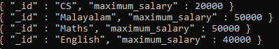

4. find the no.of employees of each dept.

Query

db.empdetails.aggregate([{$group:{_id:"$Dept",no_of_employees:{$count:{}}}}]);

Output

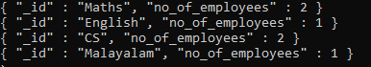

5. sort the collection empDetails in descending order of name

Query

db.empdetails.aggregate([{$sort :{name:-1}}])

Output

6. Create a text index for ‘name’ and search for names mohan and raju
Query
db.empdetails.createIndex({name:"text"})
Output
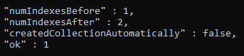
Query
db.empdetails.find({$text:{$search:"raju"}});
Output

2.create a database Inventory and create an orders collection. Apply MapReduce operation for finding the total purchase of each customer.
Query
use Inventory
switched to db Inventory
> db.createCollection("orders");
{ "ok" : 1 }
> db.orders.insert({id:1,"product":"Soap","customer":"John",orders:5});
WriteResult({ "nInserted" : 1 })
> db.orders.insert({id:2,"product":"Paste","customer":"John",orders:7});
WriteResult({ "nInserted" : 1 })
> db.orders.insert({id:3,"product":"Drinks","customer":"Kore",orders:4});
WriteResult({ "nInserted" : 1 })
> db.orders.insert({id:4,"product":"Gum","customer":"Ohil",orders:5});
WriteResult({ "nInserted" : 1 })

> var map = function() {emit(this.customer,this.orders);};
> var reduce = function(customer,orders) {return Array.sum(orders);};
> db.orders.mapReduce(map, reduce,{out: "totals"});
{ "result" : "totals", "ok" : 1 }
db.totals.find();
{ "_id" : "John", "value" : 12 }
{ "_id" : "Kore", "value" : 4 }
{ "_id" : "Ohil", "value" : 5 }
Output
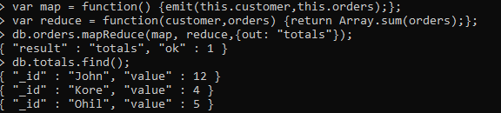

Example Queries
>db.emp1.aggregate([{$group:{_id:"$dept","avg sal":{$avg:"$sal"}}}])
> db.emp1.aggregate([{$group:{_id:"$dept","minimum sal":{$min:"$sal"}}}])
> db.emp1.aggregate([{$group:{_id:"$dept","maximum sal":{$max:"$sal"}}}])
> db.emp1.aggregate([{$group:{_id:"$dept","no of emp":{$sum:1}}}])

> db.bookdata.find().sort({"Author":1})
> db.bookdata.find().sort({"Author":-1})

> db.bookdata.createIndex({Title:"text"})
> db.bookdata.find({$text:{$search:"DBMS COA"}})

